***Case Study on Linux OS***

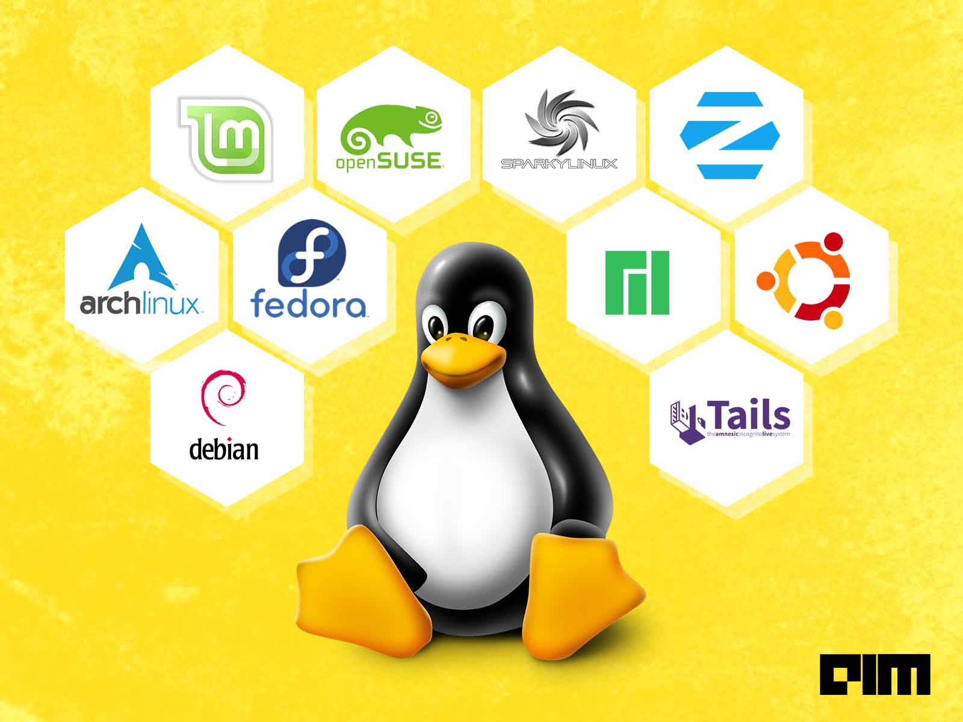

**Name : Khan Arshad Abdulla**

**Roll No : 20CO24**

**Group No : 16**

***ABSTRACT***

-<(- 5 - 5?5<0 $&

- 5F ?+$$55!

- &5 %! 5-  $ %?5

G%!5$$50(&5 %! 5'&9?5

'&9!->;33H'+#- 5

($$%! -&%- ?+- %

5 !!5'&- ?0(! 

>&%- I5

-<(- 5 - 5?5<0 $&

- 5F ?+$$55!

- &5 %! 5-  $ %?5

G%!5$$50(&5 %! 5'&9?5

'&9!->;33H'+#- 5

($$%! -&%- ?+- %

5 !!5'&- ?0(! 

>&%- I5

-<(- 5 - 5?5<0 $&

- 5F ?+$$55!

- &5 %! 5-  $ %?5

G%!5$$50(&5 %! 5'&9?5

'&9!->;33H'+#- 5

($$%! -&%- ?+- %

5 !!5'&- ?0(! 

>&%- I5

-<(- 5 - 5?5<0 $&

- 5F ?+$$55!

- &5 %! 5-  $ %?5

G%!5$$50(&5 %! 5'&9?5

'&9!->;33H'+#- 5

($$%! -&%- ?+- %

5 !!5'&- ?0(! 

>&%- I5

-<(- 5 - 5?5<0 $&

- 5F ?+$$55!

- &5 %! 5-  $ %?5

G%!5$$50(&5 %! 5'&9?5

'&9!->;33H'+#- 5

($$%! -&%- ?+- %

5 !!5'&- ?0(! 

>&%- I5

-<(- 5 - 5?5<0 $&

- 5F ?+$$55!

- &5 %! 5-  $ %?5

G%!5$$50(&5 %! 5'&9?5

'&9!->;33H'+#- 5

($$%! -&%- ?+- %

5 !!5'&- ?0(! 

>&%- I5

-<(- 5 - 5?5<0 $&

- 5F ?+$$55!

- &5 %! 5-  $ %?5

G%!5$$50(&5 %! 5'&9?5

'&9!->;33H'+#- 5

($$%! -&%- ?+- %

5 !!5'&- ?0(! 

>&%- I5

-<(- 5 - 5?5<0 $&

- 5F ?+$$55!

- &5 %! 5-  $ %?5

G%!5$$50(&5 %! 5'&9?5

'&9!->;33H'+#- 5

($$%! -&%- ?+- %

5 !!5'&- ?0(! 

>&%- I5?

-<(- 5 - 5?5<0 $&

- 5F ?+$$55!

- &5 %! 5-  $ %?5

G%!5$$50(&5 %! 5'&9?5

'&9!->;33H'+#- 5

($$%! -&%- ?+- %

5 !!5'&- ?0(! 

>&%- I5?

-<(- 5 - 5?5<0 $&

- 5F ?+$$55!

- &5 %! 5-  $ %?5

G%!5$$50(&5 %! 5'&9?5

'&9!->;33H'+#- 5

($$%! -&%- ?+- %

5 !!5'&- ?0(! 

>&%- I5?

The Linux operating system occupies a special position in the world of computer science. Unlike the great majority of operating systems, which are produced by commercial developers and sold at a profit, Linux is produced and maintained by a coterie of enthusiastic volunteers, and is distributed with no license fees whatsoever. It is available in several versions that run with nearly identical look and feel on a diverse group of hardware platforms. Linux is famed both for its stability and for its efficiency, often running for months, or occasionally years at a time without having to be rebooted, while also achieving excellent performance. It conveys many of the properties of UNIX that have made that operating system extremely popular among computer science professionals. Linux source code is as freely available as the executable code, thus giving users complete freedom to modify and adapt the operating system to the special needs of their systems. Linux maintains the tradition of openness and voluntarism that originally characterized the UNIX world, while at the same time avoiding the concomitant fragmentation experienced by UNIX into a variety of dialects. Linux is likely to continue to increase in importance.

Many software systems do not have documented system architecture. These are often large, complex systems that are difficult to understand and maintain. One approach to recovering the understanding of a system is to extract architectural documentation from the system implementation. To evaluate the effectiveness of this approach, we extracted architectural documentation from the LinuxTM kernel. The Linux kernel is a good candidate for a case study because it is a large (800 KLOC) system that is in widespread use and it is representative of many existing systems.

***INTRODUCTION***

Linux is an operating system that evolved from a kernel created by Linus Torvalds when he was a student at the University of Helsinki. To say that Linux is an operating system means that it's meant to be used as an alternative to other operating systems, Windows, Mac OS, MS-DOS, Solaris and others. Linux is not a program like a word processor and is not a set of programs like an office suite. Linux is an interface between computer/server hardware, and the programs which run on it. As an open operating system, Linux is developed collaboratively, meaning no company is solely responsible for its development or ongoing support. Linux is rooted in the community of software developers dedicated to producing a quality operating system. The human readable instructions that realize the Linux operating system are freely available. These instructions are collectively called source code. This makes Linux an open source operating system. Linux is licensed under the GNU General Public Licenses (GPL). This ensures that the source code will always be freely available to anyone wants it. Due to this, Linux rapidly accumulated developers and users who adapted code from other free software projects for use with the new operating system. Any person, with some programming knowledge, can build their own customized Linux system. There are also many distributions available to download on the internet. Few examples are Ubuntu, Linux Mint, Arch-Linux and more. Best part of Linux is that it is free to use, and it always will be.

These days, Linux is vastly used by many companies for web hosting/servers. Google itself totally uses Linux for their servers. This is because Server versions of Windows can cost, depending on the specific edition, several thousand dollars per copy. Linux also offers excellent compatibility with various different architectures that makes it an ideal choice for servers. Linux has proven to be a tremendously stable and versatile operating system as a network server. When Linux is deployed as a web server or in corporate networks, its down-time is almost negligible. There have been cases when Linux servers have been running for more than a year without re-booting and then only taken down for a brief period for routine maintenance. Its cost effectiveness has sold it more than anything else.

The focal point of any operating system is its 'kernel'. The Linux kernel in a Linux OS is what tells the CPU of your computer to do what you want the program that you're using to do. Without a kernel, an operating system doesn't exist. Without programs, a kernel is useless. The Linux kernel has received contributions from thousands of programmers. All Linux distributions released have been based upon the Linux kernel.

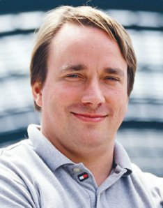

***Linus Torvalds***

***HISTORY***

**Linux**, computer [operating system](https://www.britannica.com/technology/operating-system) created in the early 1990s by Finnish software engineer [Linus Torvalds](https://www.britannica.com/biography/Linus-Torvalds) and the [Free Software Foundation](https://www.britannica.com/topic/Free-Software-Foundation) (FSF).

While still a student at the University of Helsinki, Torvalds started developing Linux to create a system similar to MINIX, a [UNIX](https://www.britannica.com/technology/UNIX) operating system. In 1991 he released version 0.02; Version 1.0 of the Linux kernel, the core of the operating system, was released in 1994. About the same time, American software developer [Richard Stallman](https://www.britannica.com/biography/Richard-Stallman) and the FSF made efforts to create an [open-source](https://www.britannica.com/topic/open-source) UNIX-like operating system called GNU. In contrast to Torvalds, Stallman and the FSF started by creating utilities for the operating system first. These utilities were then added to the Linux kernel to create a complete system called GNU/Linux, or, less precisely, just Linux.

Linux grew throughout the 1990s because of the efforts of hobbyist developers. Although Linux is not as user-friendly as the popular [Microsoft Windows](https://www.britannica.com/technology/Windows-OS) and [Mac OS](https://www.britannica.com/technology/Mac-OS) operating systems, it is an efficient and reliable system that rarely crashes. Combined with [Apache](https://www.britannica.com/technology/Apache-Web-server), an open-source Web [server](https://www.britannica.com/technology/server), Linux accounts for most of the [servers](https://www.britannica.com/technology/server) used on the [Internet](https://www.britannica.com/technology/Internet). Because it is open-source, and thus modifiable for different uses, Linux is popular for systems as [diverse](https://www.merriam-webster.com/dictionary/diverse) as [cellular telephones](https://www.britannica.com/technology/mobile-telephone) and [supercomputers](https://www.britannica.com/technology/supercomputer). [Android](https://www.britannica.com/technology/Android-operating-system), [Google](https://www.britannica.com/topic/Google-Inc)’s operating system for mobile devices, has at its core a modified Linux kernel, and Chrome OS, Google’s operating system that uses the Chrome [browser](https://www.britannica.com/technology/browser), is also Linux-based. The addition of user-friendly desktop [environments](https://www.merriam-webster.com/dictionary/environments), office suites, Web [browsers](https://www.britannica.com/technology/browser), and even games helped to increase Linux’s popularity and make it more suitable for home and office desktops. New distributions (packages of Linux software) have been created since the 1990s. Some of the more well-known distributions include MX Linux, Manjaro, Linux Mint, and Ubuntu.

***FEATURES OF LINUX***

* **Multitasking:** several programs running at the same time.
* **Multi-user:** several users on the same machine at the same time (and **no** two-user licenses!).
* **Multiplatform:** runs on many different CPUs, not just Intel.
* **Multiprocessor:** SMP support is available on the Intel and SPARC platforms (with work currently in progress on other platforms), and Linux is used in several loosely-coupled MP applications, including Beowulf systems and the Fujitsu AP1000+ SPARC-based supercomputer.
* **Multithreading:** has native kernel support for multiple independent threads of control within a single process memory space.
* Has memory protection between processes, so that one program can't bring the whole system down.
* Demand loads executables: Linux only reads from disk those parts of a program that are actually used.
* Virtual memory using paging (not swapping whole processes) to disk: allowing you to use more memory than is physically available in your computer.
* A unified memory pool for user programs and disk cache, so that all free memory can be used for caching, and the cache can be reduced when running large programs.
* Dynamically linked shared libraries (DLL’s) and static libraries too, of course.
* Mostly compatible with POSIX, System V, and BSD at the source level.
* Through an iBCS2-compliant emulation module, mostly compatible with SCO, SVR3, and SVR4 at the binary level.
* All source code is available, including the whole kernel and all drivers, the development tools and all user programs; also, all of it is freely distributable. Plenty of commercial programs are being provided for Linux without source, but everything that has been free, including the entire base operating system, is still free.
* 387-emulation in the kernel so that programs don't need to do their own math emulation. Every computer running Linux appears to have a math coprocessor. Of course, if your computer already contains an FPU, it will be used instead of the emulation, and you can even compile your own kernel with math emulation removed, for a small memory gain.
* Support for many national or customized keyboards, and it is fairly easy to add new ones dynamically.
* Multiple virtual consoles: several independent login sessions through the console, you switch by pressing a hot-key combination (not dependent on video hardware). These are dynamically allocated; you can use up to 64.
* Supports a large number of file-systems including:
  + Minix
  + HFS (Macintosh)
  + ISO 9660 (CDROM) with rockridge and/or Joliet extensions
  + MS-DOS FAT and VFAT
  + UFS (Berkeley Fast File System)
  + Amiga FFS
  + Read-only HPFS (OS/2)
* TCP/IP networking, including ftp, telnet, NFS, etc.

***ADVANTAGES***

* One of the most valued advantages of Linux ​over the other platforms lies with the high security levels it ensures.
* Every Linux ​user is happy to work in a virus-free environment and use the regular virus-prevention time needed when working with other ​Operating Systems​ for other more important tasks​. ​Thanks to its open-source distribution, ​Linux​ is being constantly developed and updated by the constantly​ ​expanding community of programmers supporting it.
* Despite its dynamic nature, it is totally complete in terms of functionality and interface. All those ongoing development efforts are made with the sole purpose of keeping the platform flexible and ever adaptable to the changeable 'climate' of the WWW.
* Certainly, the biggest advantage of the Linux system is that it is free to use. We can easily download it, and there is no need to buy the license for it. It is distributed under GNU GPL (General Public License). Comparatively, we have to pay a huge amount for the license of the other operating systems.
* Linux is more stable than other operating systems. Linux does not require to reboot the system to maintain performance levels. It rarely hangs up or slow down. It has big up-times.

***DISADVANTAGES***

* Understanding-Becoming familiar with the ​Linux Operating System​ requires patience as well as a strong learning curve. You must have the desire to read and figure things out on your own, rather than having everything done for you.
* Compatibility-Because of its free nature, ​Linux​ is sometimes behind the curve when it comes to brand new hardware compatibility. Though the kernel contributors and maintainers work hard at keeping the kernel up to date, ​Linux​ does not have as much of a corporate backing as alternative ​Operating Systems​. Sometimes you can find third party applications, sometimes you can’t.
* Alternative Programs-Though ​Linux​ developers have done a great job at creating alternatives to popular Windows applications, there are still some applications that exist on Windows that have no equivalent ​Linux Application​.
* Lack of Proprietary Software- Many big developers don’t even bother publishing their software on Linux because of its small market share. You will have to use third-party software like [Wine](https://kerneltips.com/wine-on-linux-mint-20) or use [Virtualbox](https://kerneltips.com/virtualbox-on-linux-mint-20) to get your favorite software up ad running on Linux. One such example is Adobe. No Adobe software is available for Linux, and most don’t operate properly over Wine.

***CONCLUSION***

Linux has a very bright future; many companies are choosing Linux to power their workstations and servers. Many companies are also replacing currently install UNIX and Windows machines with Linux boxes. Linux is a very stable multitasking multi-user operating system. Linux is constantly in the news, whether that is computer-related or business related. Many companies are using Linux as file servers, print servers, Web and application servers, and workstations. Linux is a scalable operating system; it can serve up an office with two personal computers or accommodate a Fortune 100 company with thousands of personal computers. You can now purchase new computer systems preinstalled with Linux, you can also purchase technical support as part of the package. Linux continues to evolve, with new kernel releases coming out regularly.

Linux being free to use, has an extremely wide scope. It is being used in almost many gadgets we buy these days. The smartphones are a great example. Android which is based off Linux is found in smartphones. Some Smart TVs also use Linux these days. Upcoming gadgets like Smart Watches, Google Glass, Gaming consoles like Ouya and more, will be using Linux as their core operating system.

Linux is also a developer’s favorite choice. Since Linux provides great environment and support for program development, it is chosen by many developers around the world. Not much can be done on a simple Windows operating system. Linux provides excellent tools like the tool-chains for compiling Linux kernels, which enable users to add custom features. Apps for Android OS are also built using Linux OS since it provides the needed SDK, tools and features which are not fully supported on other operating systems.

Also, people always used to complain about Linux's lack of games. In the next few years they may start complaining about Windows' lack of games. Valve, maker of the popular Steam gaming platform, has announced that since "Windows 8 is a "catastrophe" for PCs, they're moving their games to Linux. Their long-term plan is to make a Linux-powered PC/game device to compete with Xbox 360 and the Sony PlayStation 3.

Add in the simple fact that the old PC is no longer the heart of computing and what you end up with is a world where the most popular end-user computing devices aren't running Windows, instead they're running Android. So, without an earth-shattering blast, but quietly and in hundreds of millions of smartphones, tablets, and, increasingly PCs, Linux has already become the top operating system of all.